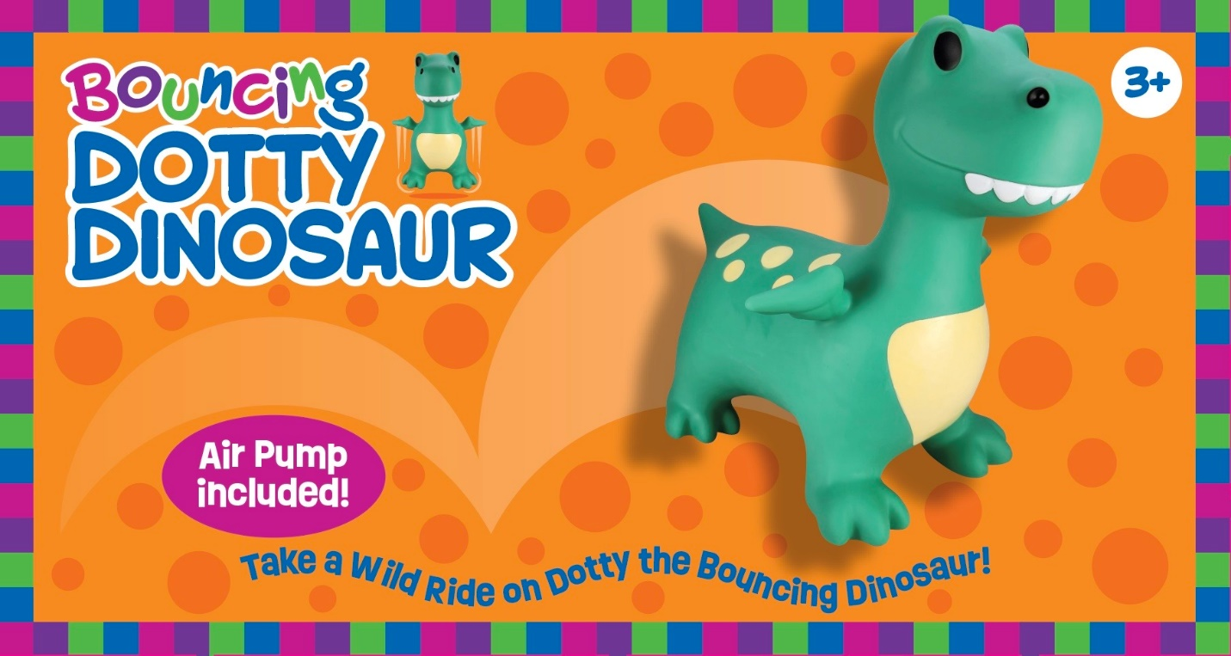
Product Name - Dotty Dinosaur
Reference Number - # OR736
UPC Number - TBA
Wholesale Cost - $15.00 each
Product Size - 23.6" x 15.7" x 21.6 " inches
Weight Capacity - 110 pounds
Packaging - Full color box with carrying handle
Contents - Dotty Dinosaur with air pump included
Age - 3 years +
Master Carton - 6 per carton

